General Contractor:
Barsh Construction Company, Tommy Fulford| David Pembleton 304 Douglas Ave.
Waco, Texas 76712
254-855-0827 Tommy Cell
254-716-5871 David Cell
tommy@barshconstruction.com

City of Woodway Contact
Mitch Davison, PE
Director of Community Services,
City of Woodway
924 Estates Drive
Woodway, Texas 76712
254-772-4050
mdavison@woodwaytexas.gov

Engineering/Surveying Contact
CP&Y, Inc.
David Marek, PE Dylan Stubbs
200 W Hwy 6 Suite 620
Waco, Texas 76712
254-772-9272
dmarek@cpyi.com
dstubbs@cpyi.com

CONTACTS
City of Woodway Street and Utility Reconstruction
CITY OF WOODWAY, TEXAS

The Project:
- Water Line Reconstruction
- Waste Water Reconstruction
- Concrete Street and Drive Approach Reconstruction

The Timeline for Construction:
- White River Drive – SUBSTANTIALLY COMPLETE
- Little River Drive – SUBSTANTIALLY COMPLETE
- Brookhollow Drive – SUBSTANTIALLY COMPLETE
- Harbor Drive – SUBSTANTIALLY COMPLETE
- The majority of outstanding items are asphalt repairs, driveway approach finish outs, mail boxes and yard repairs including sod and irrigation.

PROJECT DETAILS

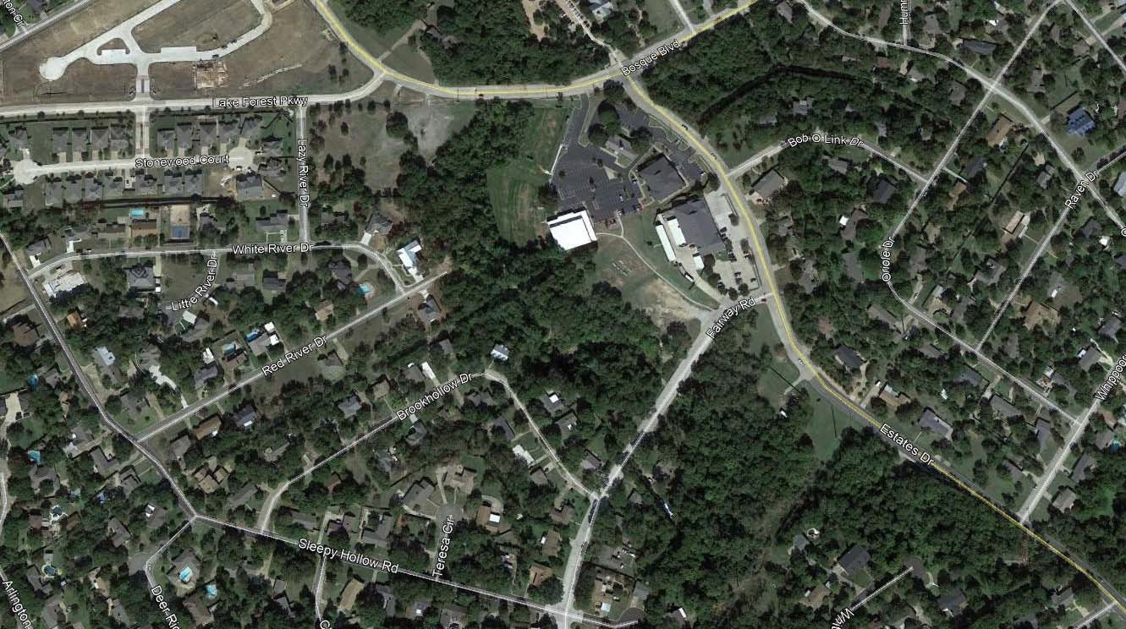
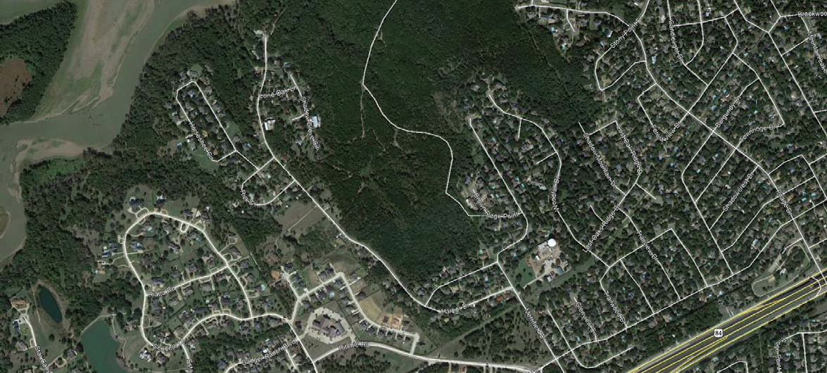
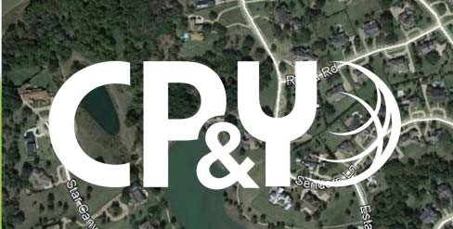
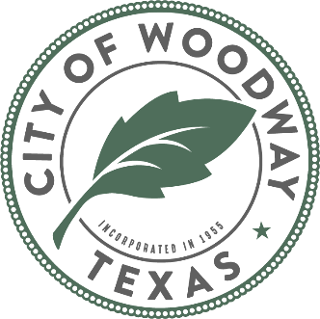
City of Woodway
2019 Street Improvements Construction Timeline

Lake Forest Pkwy
White River Drive
SUBSTANTIALLY COMPLETE
Little River Drive
SUBSTANTIALLY COMPLETE

Brook Hollow Drive
SUBSTANTIALLY
COMPLETE

Harbor Drive
SUBSTANTIALLY
COMPLETE

